You’re being robbed!

Do you know why....
....the price of food, gas, and other necessities are steadily increasing?
....you need debt to finance your life?
....your bank pays no interest on your savings?
....the rich are getting richer and the poor are getting poorer?
....the middle class is being wiped out?

The answer is:
THE FEDERAL RESERVE
The Federal Reserve steals wealth from the poor and middle class and gives it to a small group of bankers.

(turn over to learn more)
www.endthefed.org
You’re being robbed!

Do you know why....
....the price of food, gas, and other necessities are steadily increasing?
....you need debt to finance your life?
....your bank pays no interest on your savings?
....the rich are getting richer and the poor are getting poorer?
....the middle class is being wiped out?

The answer is:
THE FEDERAL RESERVE
The Federal Reserve steals wealth from the poor and middle class and gives it to a small group of bankers.

(turn over to learn more)
www.endthefed.org
..By the anti-robin hood

Here’s how they steal from you...
- The Federal Reserve is a cartel formed by the largest private banks. It stealthily operates under the guise of a “federal” agency with the pretense of “managing the economy”.

- The Federal Reserve has the power to create fiat money.
Fiat money is a piece of paper that is simply ordered by governments to be money, but is not backed by anything of real value.

- The Federal Reserve creates and then lends this “money” to the federal government or other large financial institutions. The amount of fiat money that can be created is infinite.

- Increasing the supply of money like this eventually leads to rising prices of goods, services, and assets. Those well connected to the Federal Reserve receive the money first and benefit before prices rise. It is those who receive the money last, like you, who suffer.

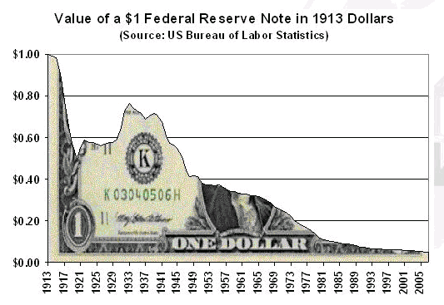
- Look at how the value of a dollar has been destroyed since the Federal Reserve was created in 1913:

Here’s the solution....
- End the Federal Reserve. Allow a free and competitive market to function. The market’s top choice for money has historically been precious metals like gold and silver which have intrinsic value, scarcity, durability, and divisibility.
..By the anti-robin hood

Here’s how they steal from you...
- The Federal Reserve is a cartel formed by the largest private banks. It stealthily operates under the guise of a “federal” agency with the pretense of “managing the economy”.

- The Federal Reserve has the power to create fiat money.
Fiat money is a piece of paper that is simply ordered by governments to be money, but is not backed by anything of real value.

- The Federal Reserve creates and then lends this “money” to the federal government or other large financial institutions. The amount of fiat money that can be created is infinite.

- Increasing the supply of money like this eventually leads to rising prices of goods, services, and assets. Those well connected to the Federal Reserve receive the money first and benefit before prices rise. It is those who receive the money last, like you, who suffer.

- Look at how the value of a dollar has been destroyed since the Federal Reserve was created in 1913:

Here’s the solution....
- End the Federal Reserve. Allow a free and competitive market to function. The market’s top choice for money has historically been precious metals like gold and silver which have intrinsic value, scarcity, durability, and divisibility.

